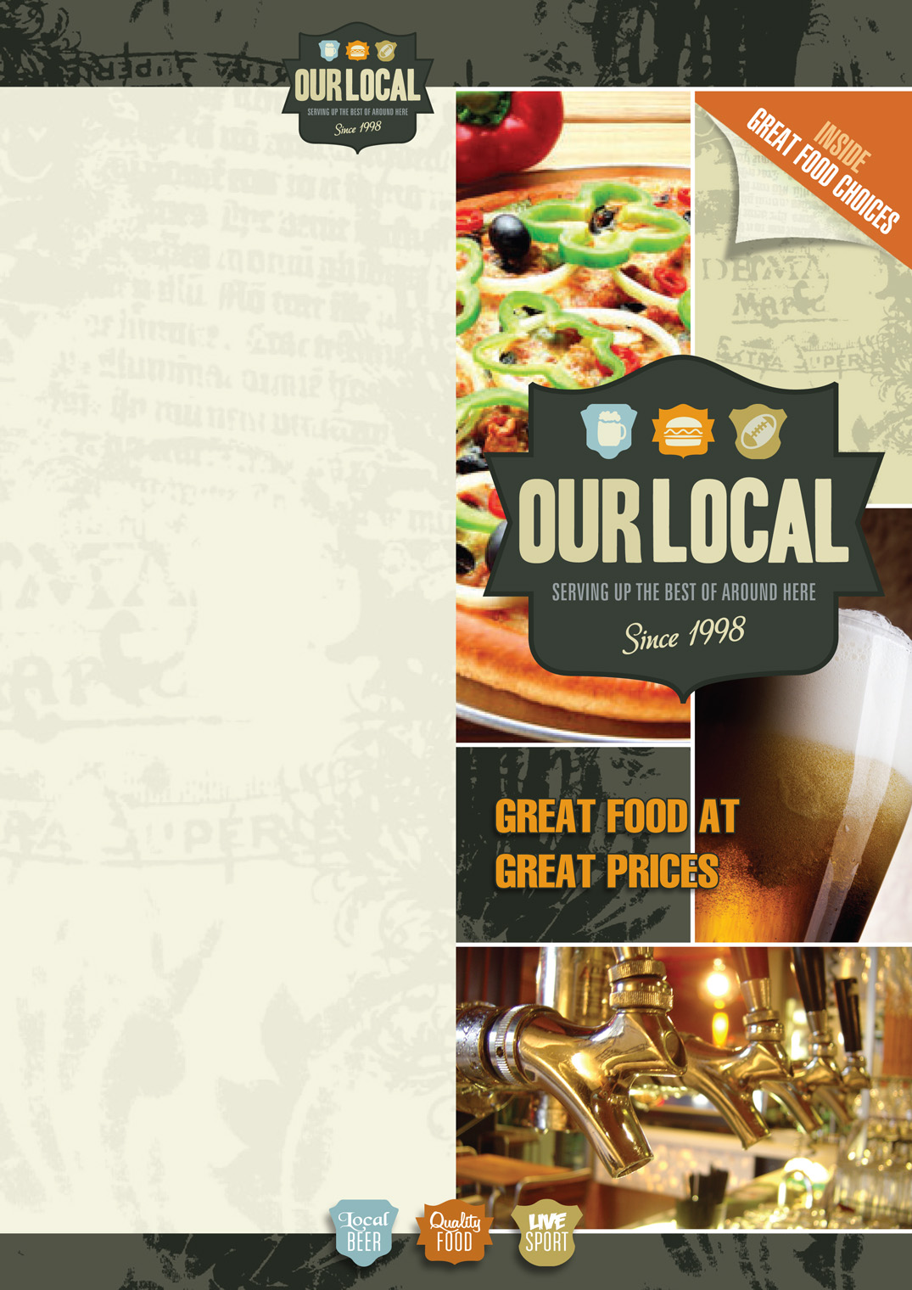

**BEVERAGES**

*NON ALCOHOLIC DRINKS*

Coke, Lemonade, Ginger Ale, Diet Coke, L&P, Orange Juice, Pineapple Juice

Glass: $2.50 Handle: $3.00

*HOT DRINKS*

Flat White, Long Black, Cappuccino,   
Mochaccino, Latte, Hot Choc

Small: $3.50 Large: $4.50

*HOUSE WINE*

Montana Chardonnay, Sauvignon Blanc   
or Pinot Gris

Glass: $6.50 Bottle: $30.00

Montana Merlot Cabernet or Pinot Noir,

Glass: $7.50 Bottle: $30.00

*PREMIUM WINE*

Oyster Bay Chardonnay, Sauvignon Blanc or Pinot Gris

Glass: $8.50 Bottle: $40.00

Shingle Peak Merlot or Pinot Noir

Glass: $8.50  Bottle: $40.00

*COCKTAILS*

Black Russian $12.00

Harvey Wall Banger $12.00

Tequila Sunrise or Vodka Sundowner $12.00

*SHAKERS*

Kamakazi $14.00

Margarita $14.00

Cosmopolitan $14.00

*RTDs*

Bottle: range from $6.50 to $8.50

*BEERS*

Handle: $6.00 Premium: $7.00-$8.00

*SPIRITS*

Single: $4.00 Double: $7.00-$9.00

*BUBBLES*

Lindauer Brut or Lindauer Fraise 200ml

Bottle: $8.00

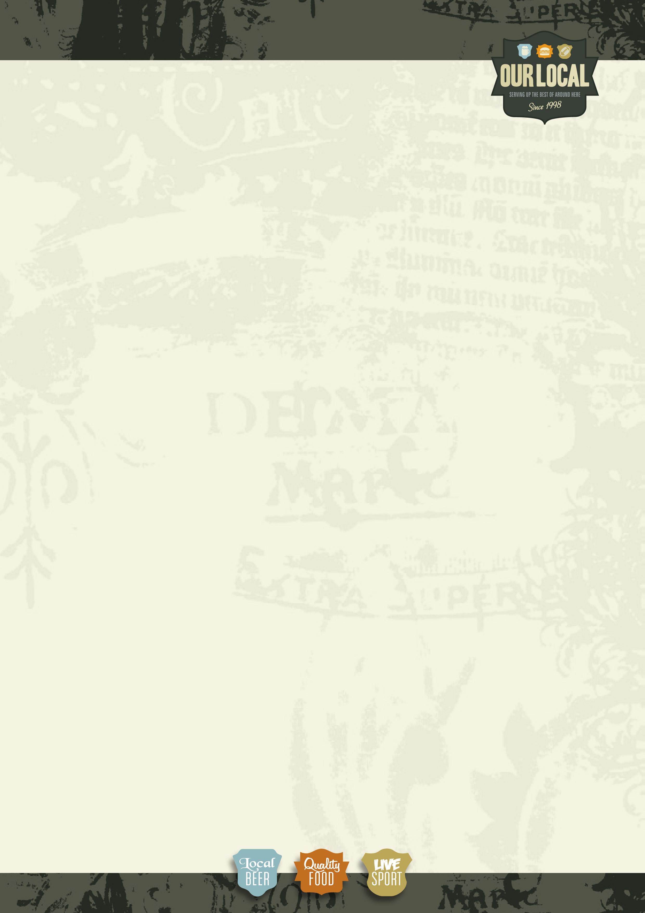

**ALL DAY BREAKFAST**

*Bacon & Eggs* $12.00

Streaky bacon, eggs cooked to your liking & Toast

*Bacon Eggs Benedict* $13.50

Poached eggs, streaky bacon & spinach served

on an English muffin topped with hollandaise sauce

*Salmon Eggs Benedict*$14.50

Poached eggs, smoked salmon & spinach served

on an English muffin topped with Hollandaise sauce

*3 Egg Omelet*$14.50

With bacon, cheese & mushroom

*Big Breakfast*$16.50

Streaky bacon, sausage, eggs, hash brown,

tomato & served with toast

**ENTREE**

*Garlic bread*  $4.00

Toasted Italian roll and garlic butter

*Cheesy Garlic Bread* $4.50

Toasted Italian roll garlic butter and cheese

*Soup of the Day*$7.50

Served with Toasted Turkish Bread

*Loaded Wedges* $10.50

Topped with bacon, melted cheese, Sour cream

& sweet chili Sauce

*Chili Beef Nachos* $10.50

Chili Beef Mince With toasted corn chips cheese,

sour cream & Salsa

*Garlic & Rosemary Prawns* $13.50

Sautéed Prawns in a Creamy Rosemary &

Garlic Sauce

*Golden Calamari* $13.50

Calamari Coated in a golden herb & Crumb coating

with Salad & Tartare Sauce

*Crumbed Scallops* $ 14.50

Golden Crumbed Scallops served with Salad &

Tartare Sauce

*Local Tenders* $15.00

Crispy golden Chicken Tenders Served with salad

& fries Our Local Sauce

KIDS MEALS

**(for children 12yrs and under)**

*Kids 2 course meal and drink* $10.00

* Chicken Nuggets and Fries or Fish n chips or Burger and Fries or Pizza and Fries or Mini Hot Dogs
* One Ice Cream Sundae with Choc or berry sauce
* One Complimentary Drink

**EXTRAS**

*Egg cooked to liking*$1.50

*Hash Brown*$2.00

*Grilled Tomatoes*$2.50

*Side of Chunky Fries w/ Chicken salt*$3.50

*Streaky Bacon*$3.50

*Side of Mushroom Sauce*$4.00

*Side of Vegetables*$4.50

*Side of Salad*$4.50

DESSERTS

**Warm Chocolate Brownie**

Whipped cream Scoop of ice-cream and Choc Sauce

**Traditional Ice-cream sundae**

with whipped cream and topping

**Chocolate Mud Cake**

Chocolate Ganache with whipped cream and berries

$6.00ea

**PIZZA’S**

*Hawaiian* $9.00

Ham and pineapple topped with grated cheese

*BBQ Chicken* $10.00

Chicken, bacon, mushroom topped with grated cheese

& BBQ Swirl

*Sweet Chili Prawn*$13.00

Grilled Prawns, topped with Grated cheese &

Sweet Chili swirl

*Meat Lovers* $13.00

Chicken, bacon, Ham and pepperoni topped with

grated cheese

**BURGERS**

*Hearty Beef* $14.50

Prime Beef patty & salad served with fries

*Chicken n Bacon*$15.50

Seared chicken breast, crispy bacon, salad served with fries

*Fish* $15.50

Fish of the Day, melted cheese and salad served with fries

*Our Local* $17.50

Prime Beef patty, bacon, steak, egg & salad served with fries

*Open Chicken or Steak Sandwich* $14.50

Prime Beef of chicken, meat, fresh salad, onion jam

on a toasted Turkish bread served with fries

**SALADS**

*Cajun Chicken*$10.00

Seared Cajun chicken served with fresh salad & spicy dressing

*Chicken Caesar*$10.50

Fresh Lettuce, crispy bacon, chicken, croutons, Parmesan cheese with Caesar dressing

*Thai Beef*$10.50

Marinated Beef with fresh salad and crispy noodles

*Calamari*$12.50

Fresh Garden salad topped with crispy crumbed calamari

*Seafood* $16.00

Assorted seafood with fresh salad & special dressing

**MAINS**

*Chicken & Bacon Fettuccini*$15.50

Grilled chicken breast, bacon cooked in a creamy parmesan sauce

*Fish n chips*$15.50

Fish of the Day served with 2 fried eggs garden salad n fries

*Garlic Prawn Fettuccini* $18.00

Sautéed prawns cooked in a creamy garlic sauce & topped with parmesan cheese

*Pork BBQ Ribs*$23.00

BBQ marinated Pork ribs served with salad and fries or

mashed potatoes and vegetables

*Prime Sirloin Steak*$23.00

Grilled Steak cooked to your liking, Served with salad & fries

& your choice of Red wine jus, creamy mushroom or Garlic Aioli sauce

*Prime Rump Steak* $23.00

Served with salad & fries & your choice of Red wine jus or creamy mushroom or Garlic Aioli sauce

*Lamb Shanks*

Slow roasted lamb shanks served with garlic mash & seasonal vegetables & minted jus

Single $22.00 Double $28.00

*Vegetarian Menu offered on request*

*\*Weekly Chefs Specials Refer to Board*