Bar Snacks  Garlic bread  Squid rings  Fries  Wedges with cheese, sour cream & sweet chili  Mac & cheese bites  Jalapeno poppers  Fish bites  Chicken bites  Spring rolls  Samosas | $8  $10  $8  $12  $10  $10  $10  $10  $8  $8 |  | Pizzas  Margarita  Pulled chicken, tomato, sweet corn, sweet chili, cheese  BBQ pulled pork, red onion, BBQ sauce, cheese  Hawaiian  Toasties  Add fries for $4 extra  Cheese  Ham, cheese & tomato  Chicken, sweetcorn, cheese  BBQ pulled pork, cheese | $14  $16.5  $16.5  $15  $6  $8  $9  $9
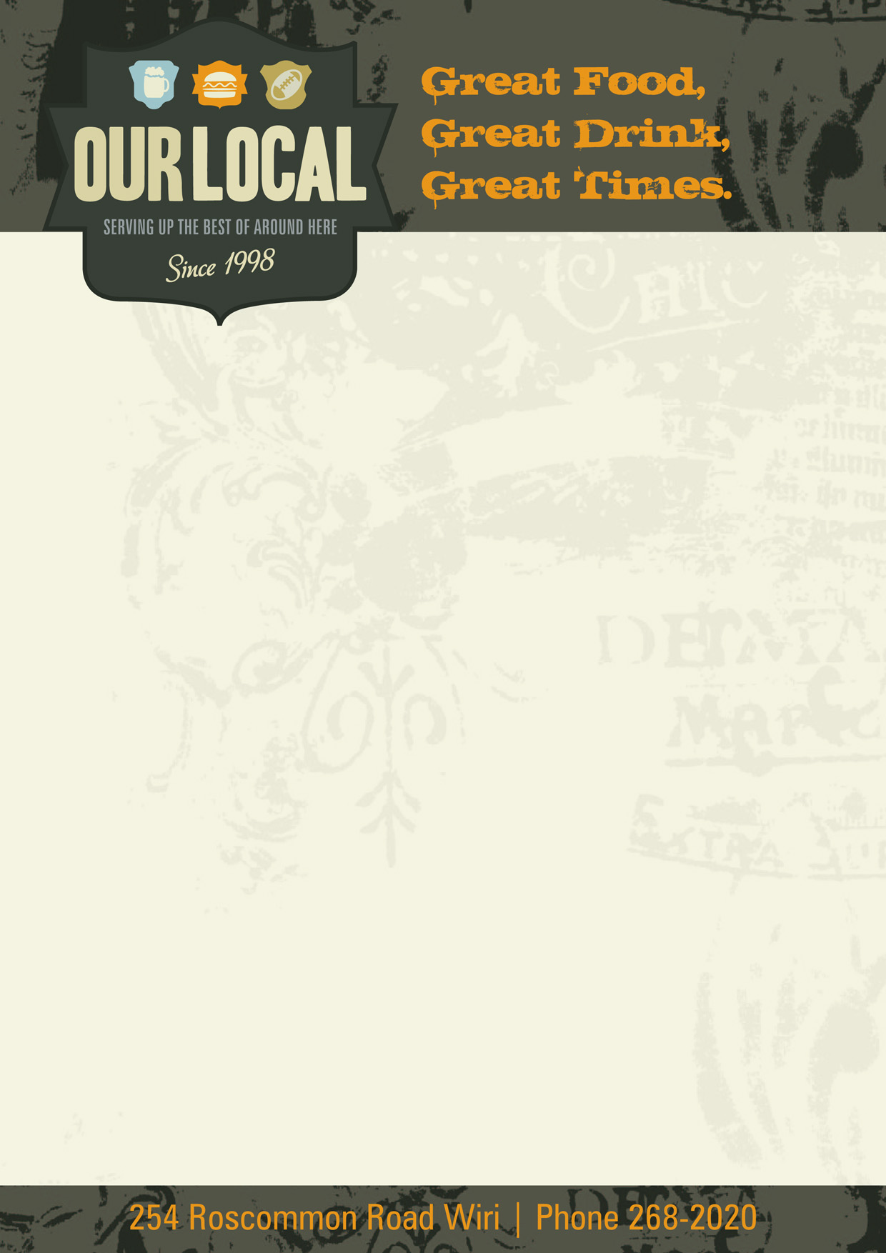

Menu

